**1. Header**

**1.1.** Logo

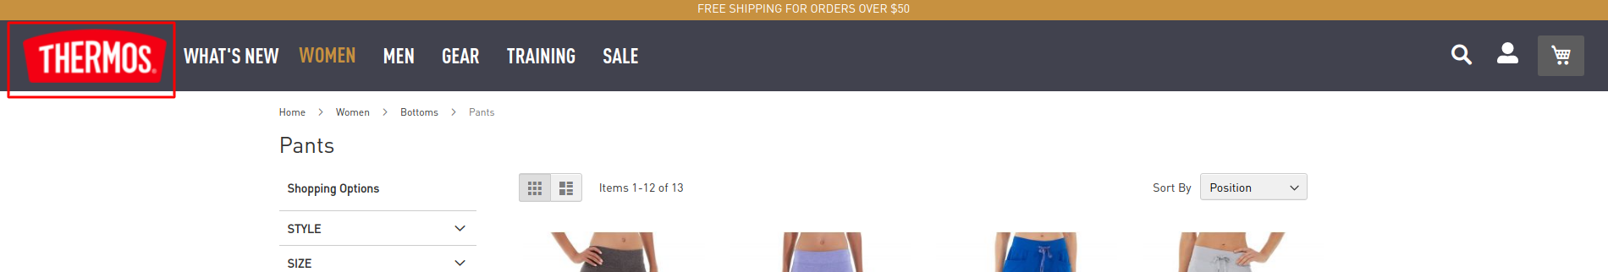

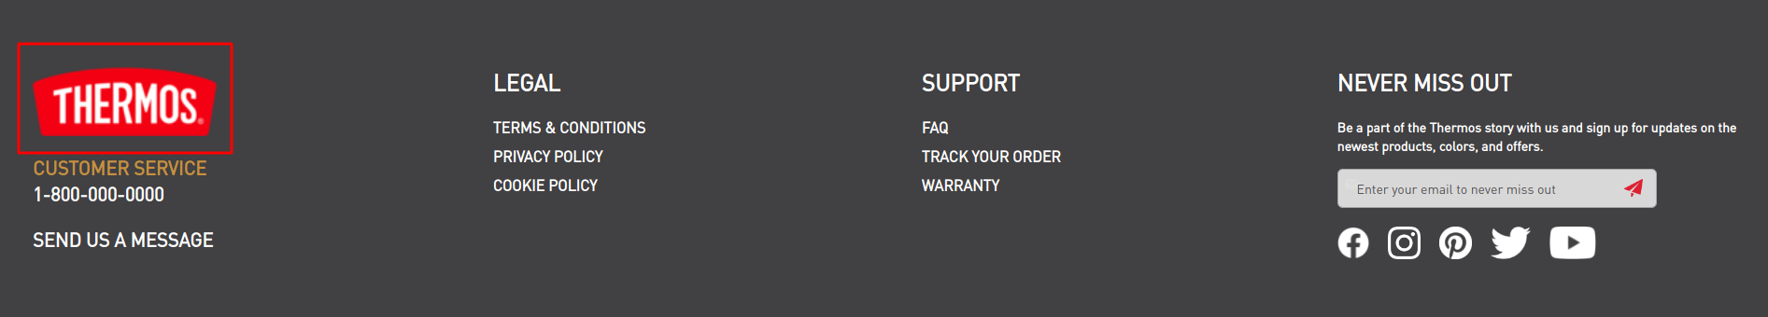

Admin panel – Content – Design – Configuration – Edit Theme – Header – Upload Logo

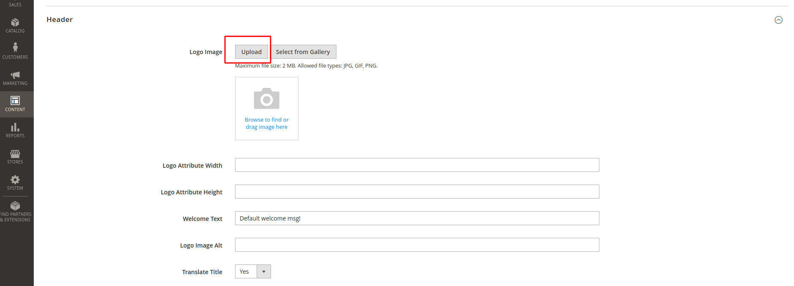

**1.2** Header Promo Block

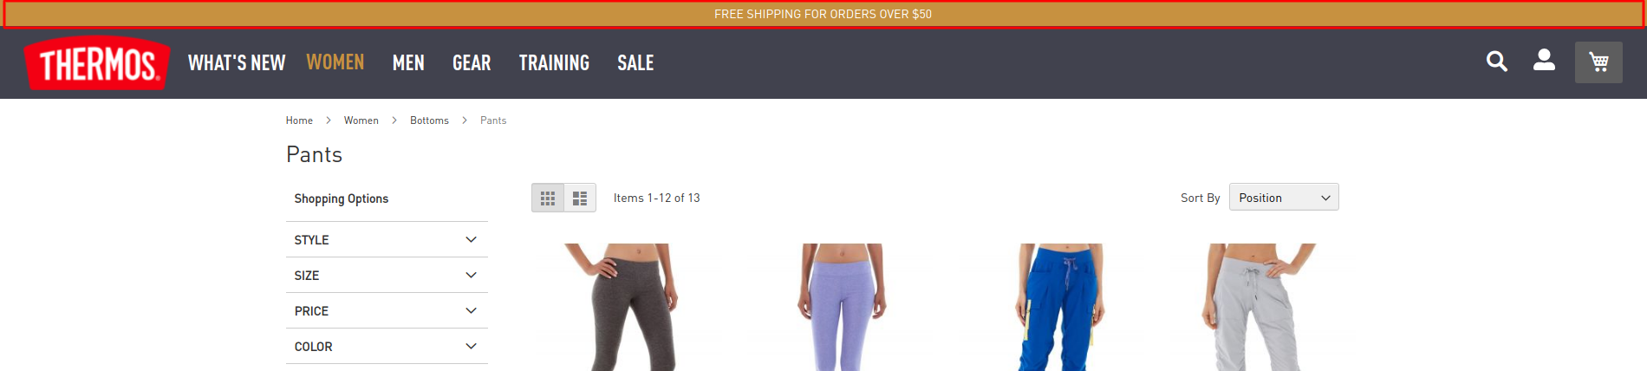

cms block id = ‘header-top-strip-promo’

In the Pagebuilder create Html Code (in the following CMS Blocks and Pages do the same)

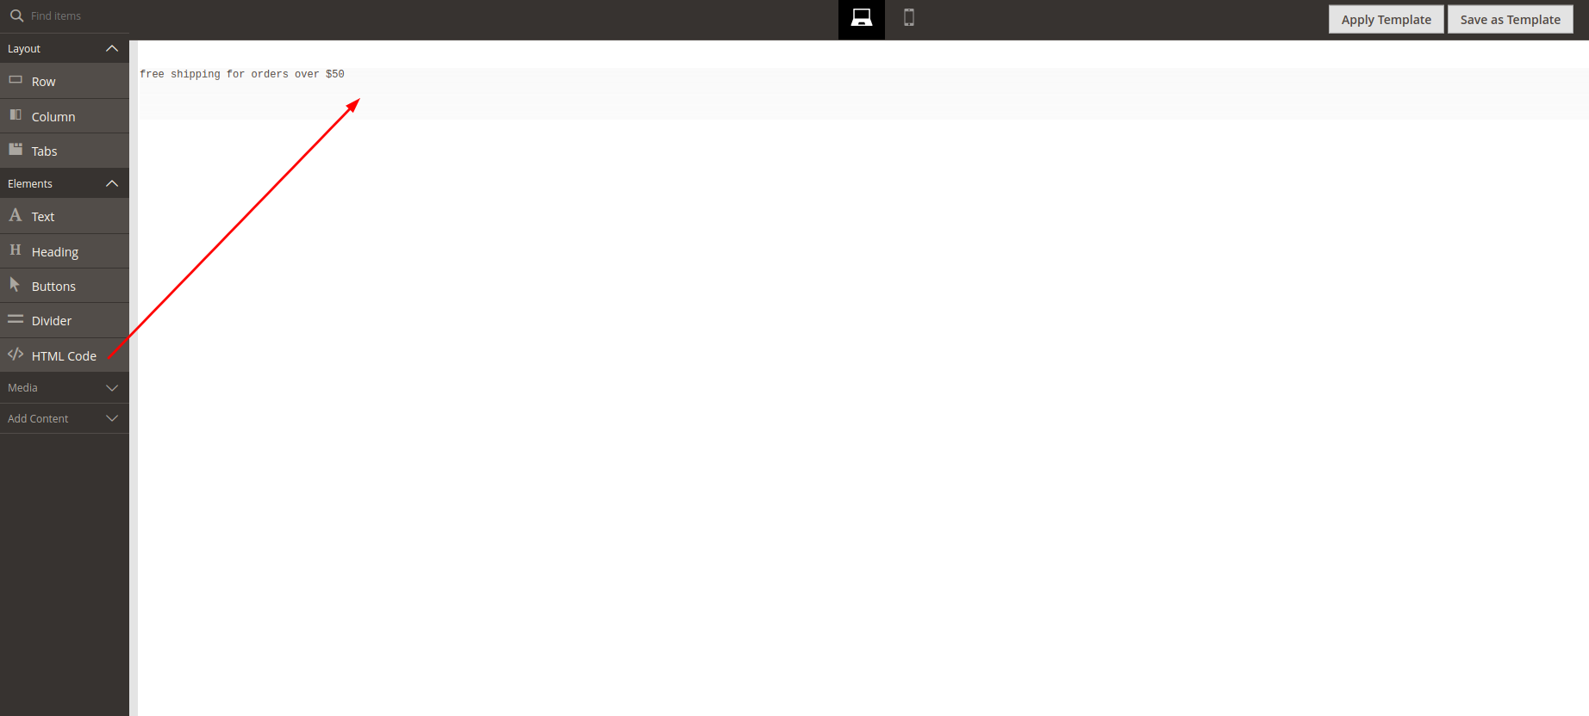

**1.3.** Image for category menu.

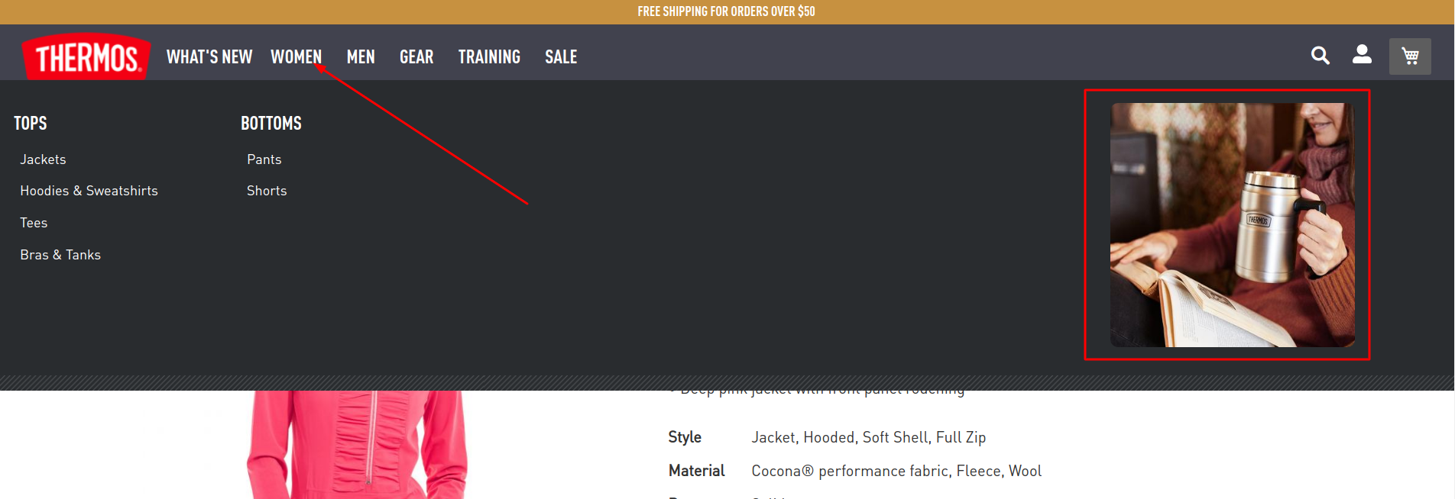

Admin panel – Catalog – Categories - Choose your category – Content

Add image

Source: app/code/KozakGroup/MenuImageCategory/registration.php

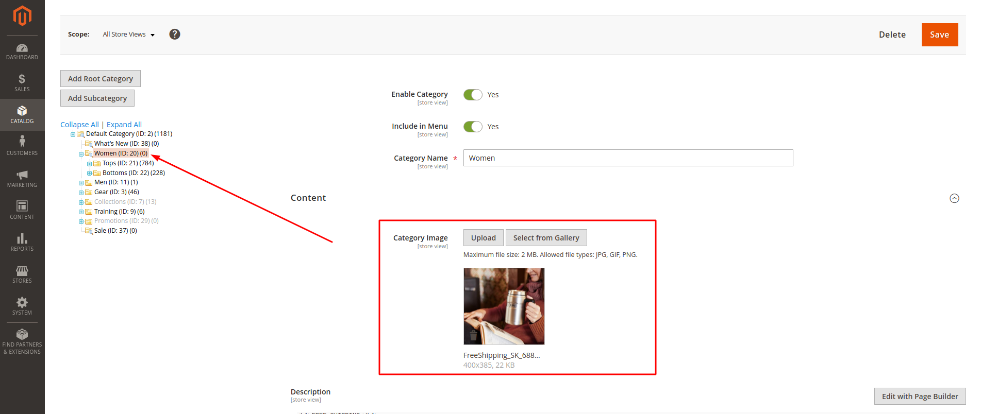

**2. Footer**

**2.1** Title for newsletter block

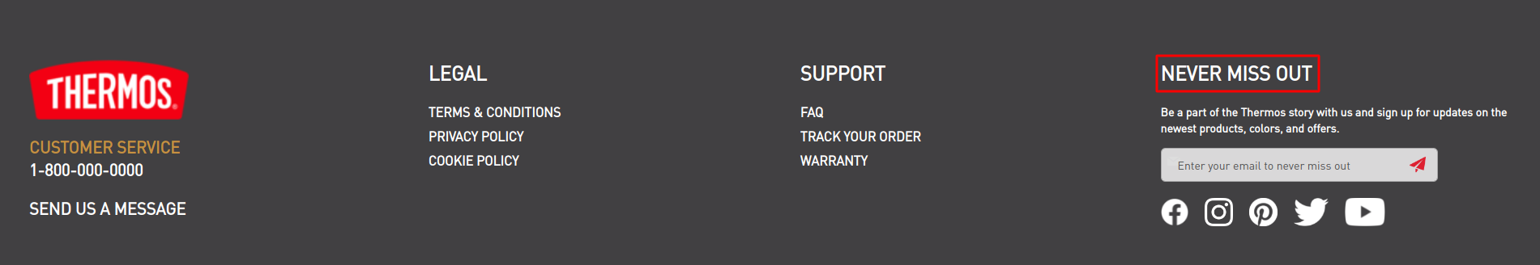

cms block id = ‘footer_newsletter_block_title’

<p class="statement">Never miss out</p>

**2.2.** Social block

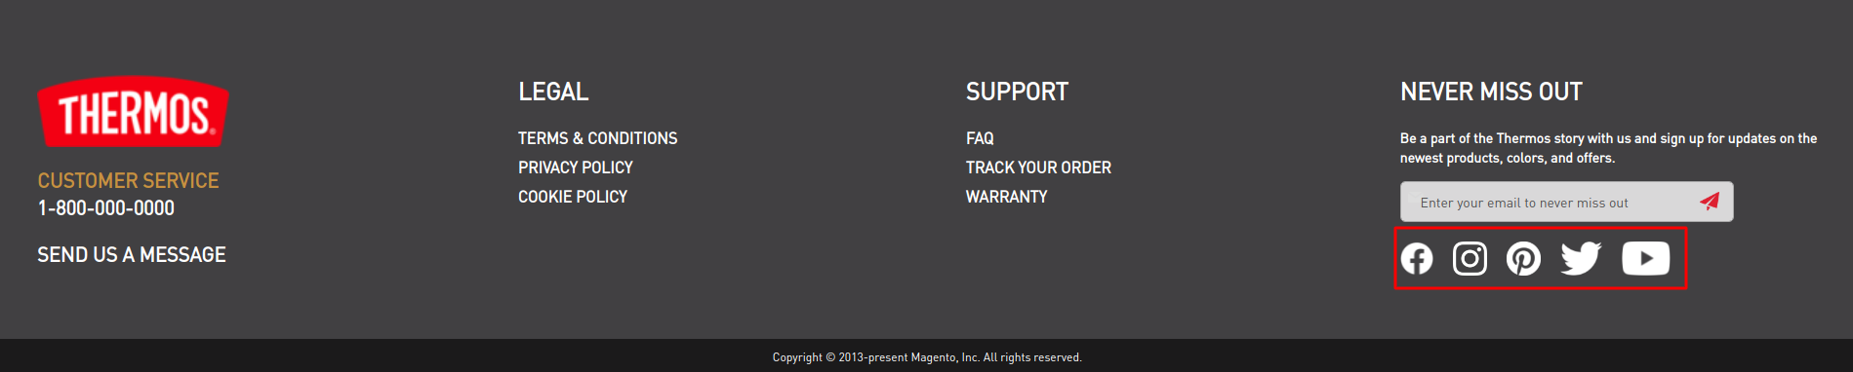

cms block id = ‘footer_social_block’

<ul class="no-bullets footer__social">

<li><a href="https://www.facebook.com/" target="_blank"><img src="{{view url='images/facebook.png'}}" alt="" /></a></li>

<li><a href="https://www.instagram.com/" target="_blank"><img src="{{view url='images/insta.png'}}" alt="" /></a></li>

<li><a href="https://www.pinterest.com/" target="_blank"><img src="{{view url='images/pinterest.png'}}" alt="" /></a></li>

<li><a href="https://twitter.com/" target="_blank"><img src="{{view url='images/twitter.png'}}" alt="" /></a></li>

<li><a href="https://www.youtube.com/" target="_blank"><img src="{{view url='images/youtube.png'}}" alt="" /></a></li>

</ul>

**2.3.** Footer links

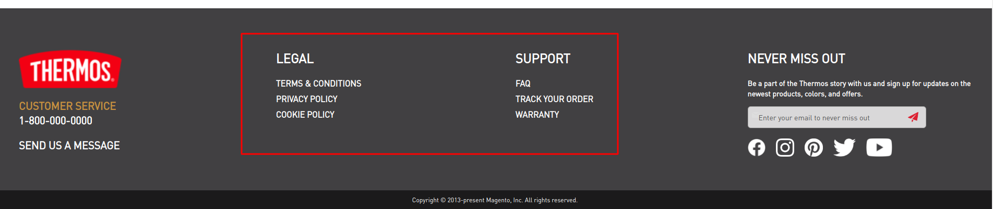

cms block id = ‘footer_links’

<div class="footer links">

<div class="nav item">

<div class="selected">

<p class="statement">Legal</p>

</div>

<ul class="section">

<li><a href="{{store url='customer-service'}}">Terms & Conditions</a></li>

<li><a href="{{store url='privacy-policy'}}">Privacy Policy</a></li>

<li><a href="{{store url='cookie-policy'}}">Cookie Policy</a><li>

</ul>

</div>

<div class="nav item">

<div class="selected">

<p class="statement">Support</p>

</div>

<ul class="section">

<li><a href="{{store url='faq'}}">Faq</a></li>

<li><a href="{{store url='sales/guest/form'}}">Track Your Order</a></li>

<li><a href="{{store url='warranty'}}">Warranty</a><li>

</ul>

</div>

</div>

**2.4.** Under logo block

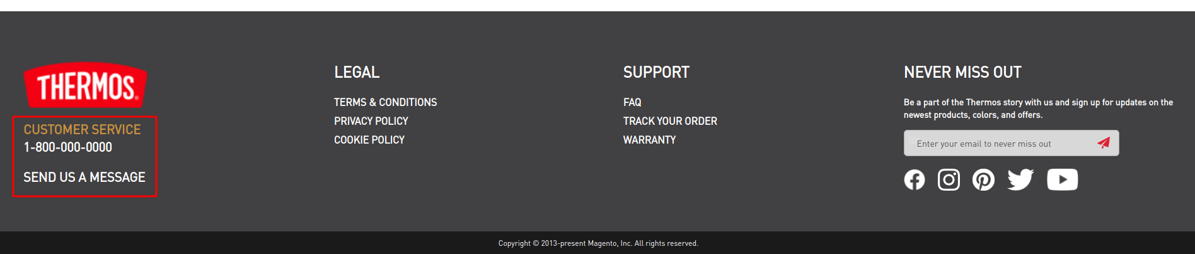

cms block id = ‘footer_after_logo_block’

<div class="service">

<p class="title">Customer Service</p>

<p>1-800-000-0000</p>

</div>

<div class="message">

<a href="{{store url='contact'}}">Send Us A Message</a>

</div>

**2.5.** Copyright Block

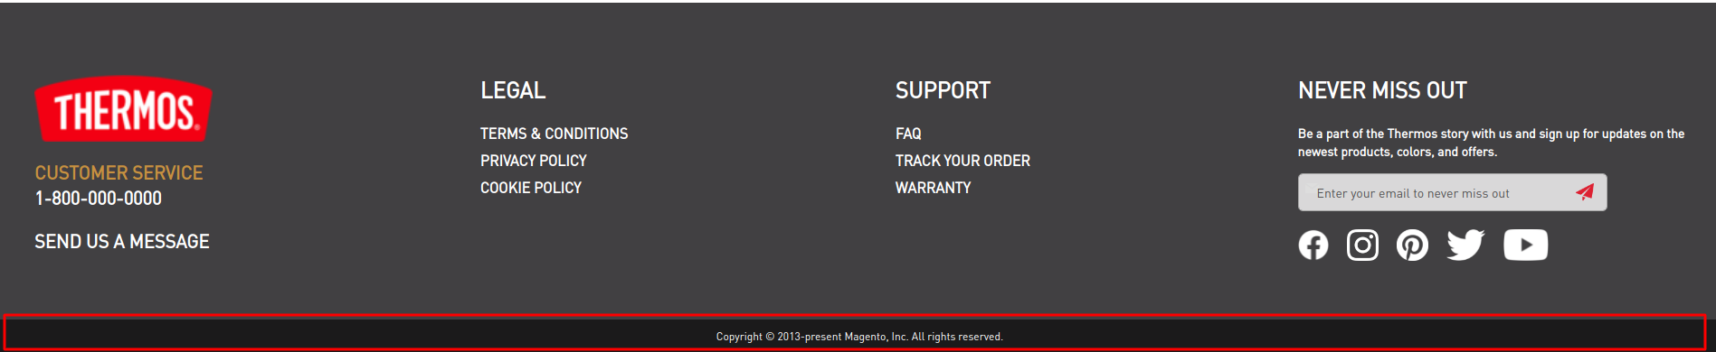

Admin panel – Content – Design – Configuration – Edit Theme – Footer – Copyright

**3.Cart**

Scroll when more than three products

Admin panel – Stores – Configuration – Sales – Checkout – Mini Cart - Number of Items to Display Scrollbar – 3

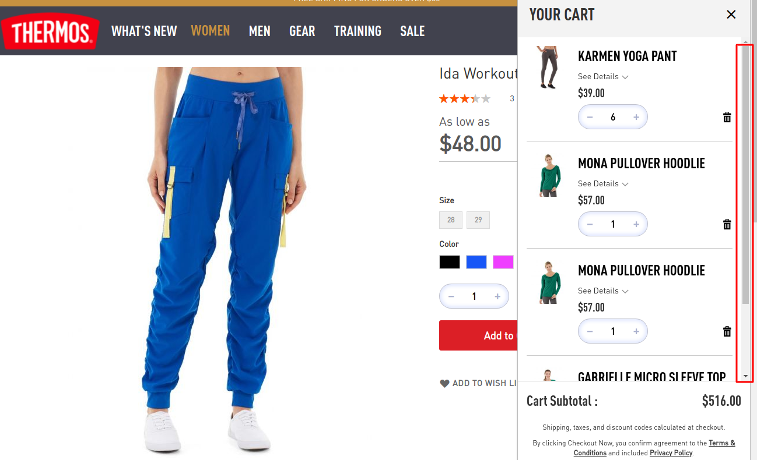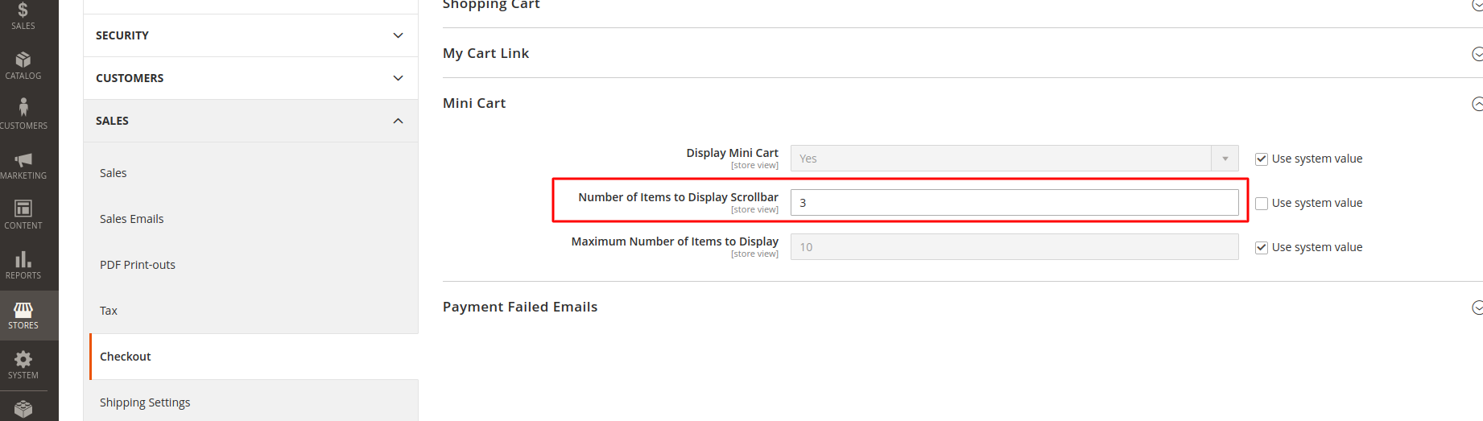

**5. Category page (PLP)**

**5.1.** Banner for Category

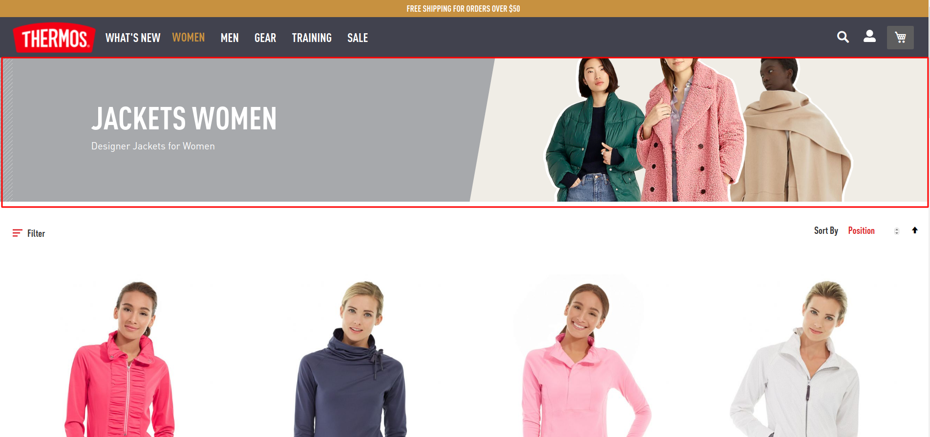

Admin panel – Catalog – Categories - Choose your category – Content

Add image and add Description

Description:

<div class="banner-wrapper">

<h1>Jackets women</h1>

<p>Designer Jackets for Women</p>

</div>

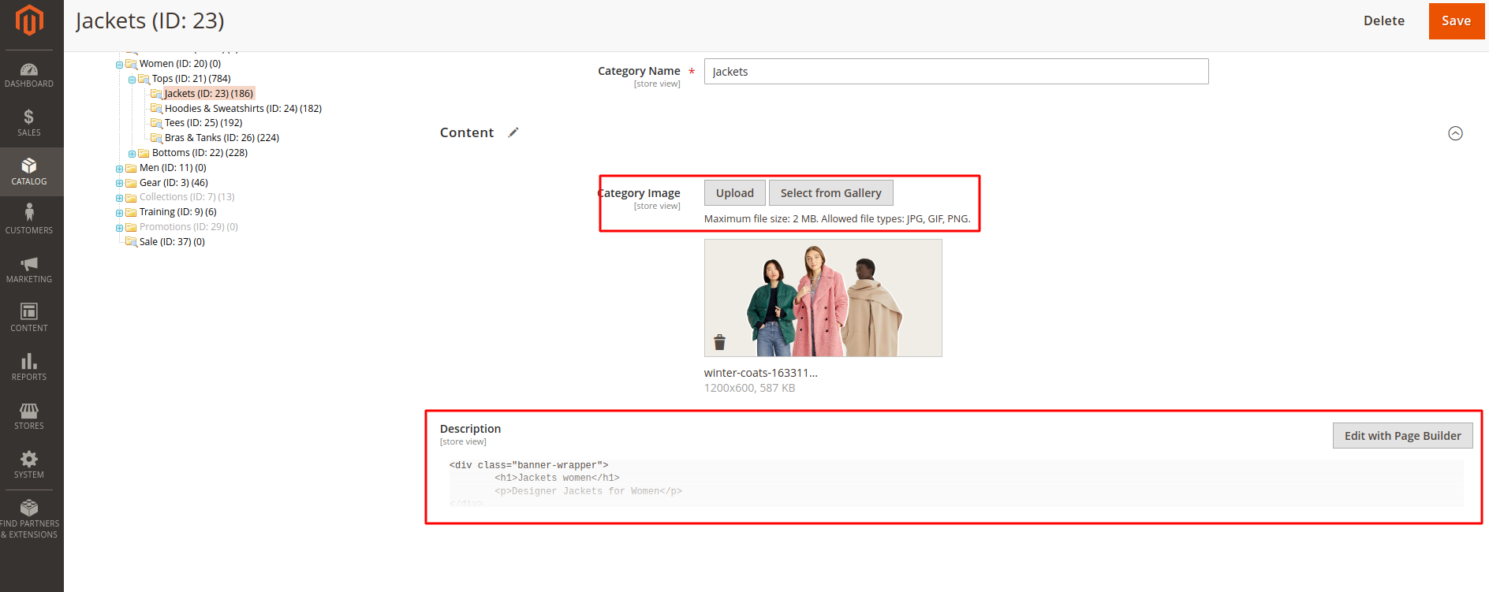

**4.Product page**

**4.1.** Hide Swatch Tooltip

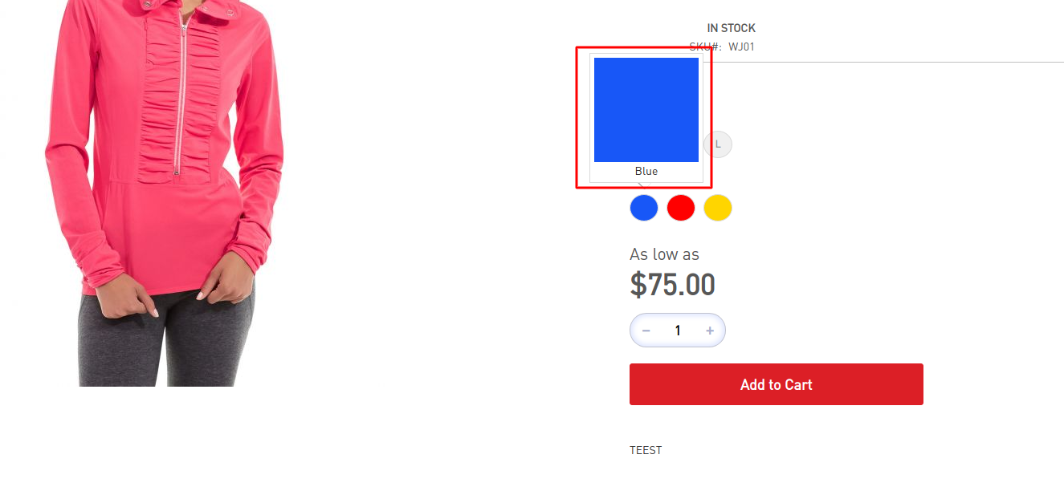

Stores ->Configuration ->Catalog ->Catalog ->Storefront ->Show Swatch Tooltip – No

**4.2** Add content for Description attribute

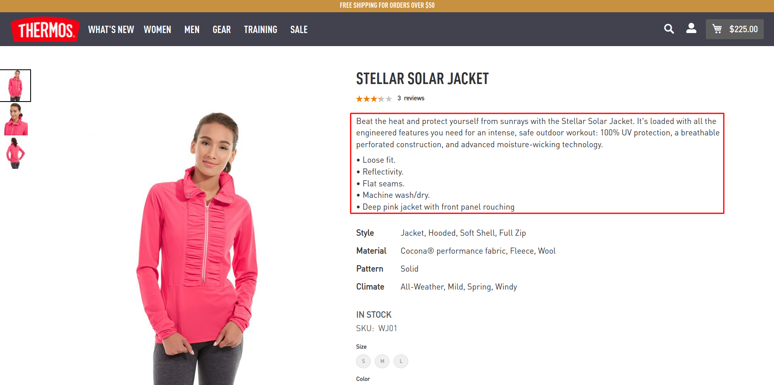

Admin panel – Catalog – Products – Сhoose the necessary product – Description

add

<p>Your text</p>

**4.3** Add content for Additional attribute

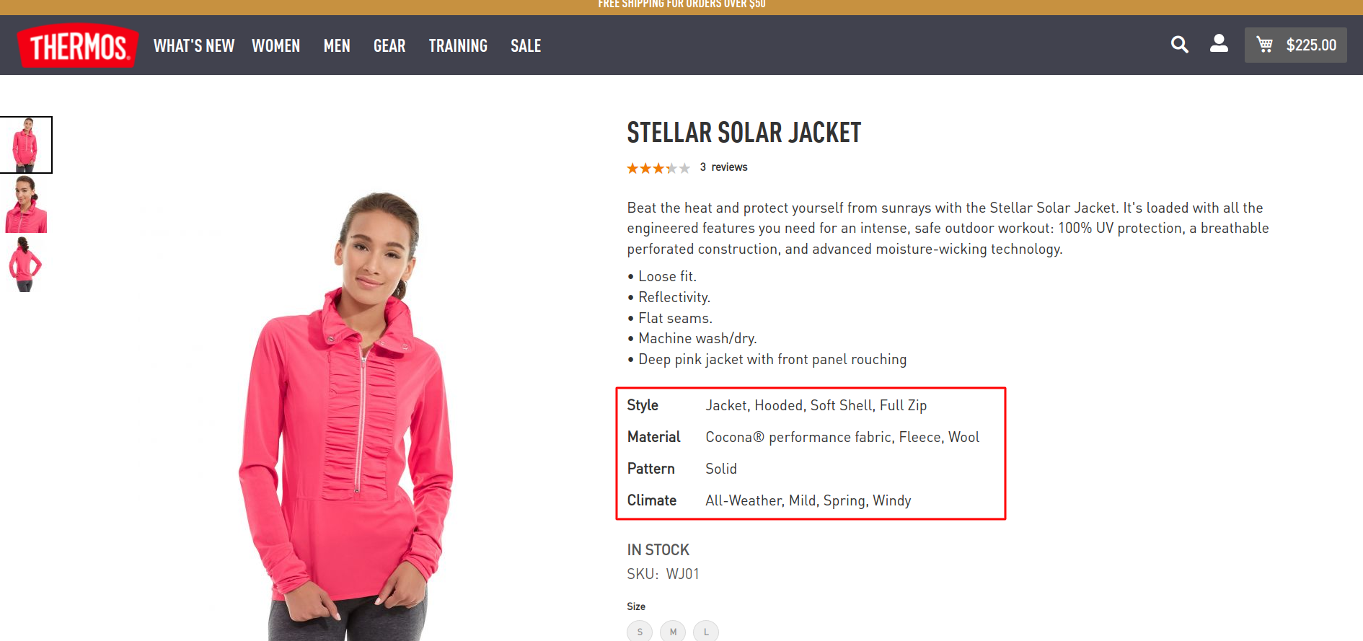

Admin panel – Catalog – Products – Сhoose the necessary product

**4.4** Add content for Overview attribute

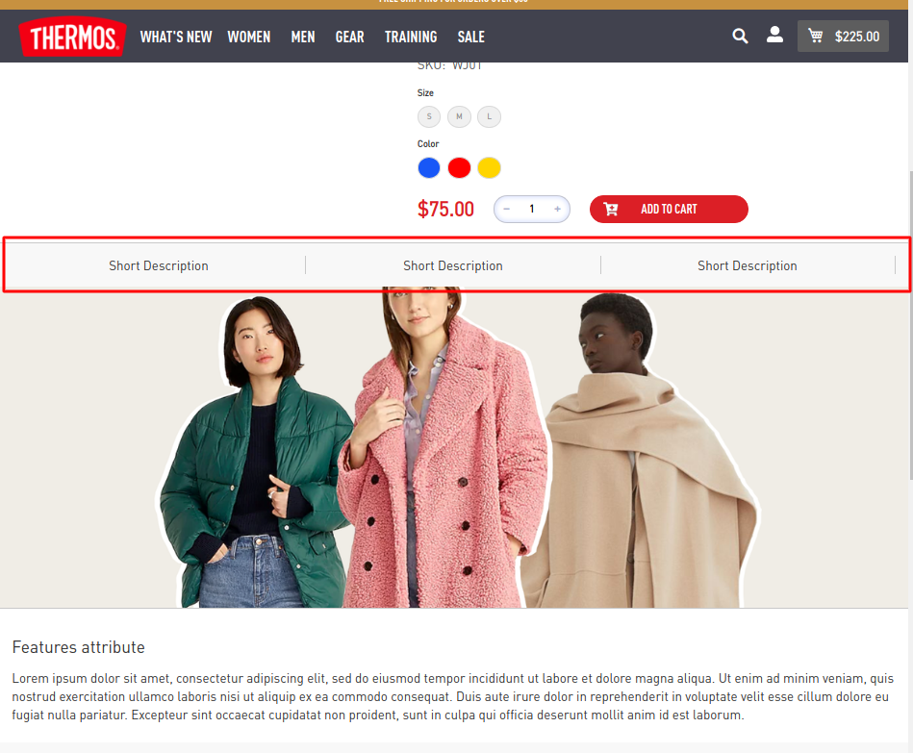

Admin panel – Catalog – Products – Сhoose the necessary product - Short Description

<ul>

<li>Short Description</li>

<li>Short Description</li>

<li>Short Description</li>

</ul>

**4.5** Add content for Image attribute

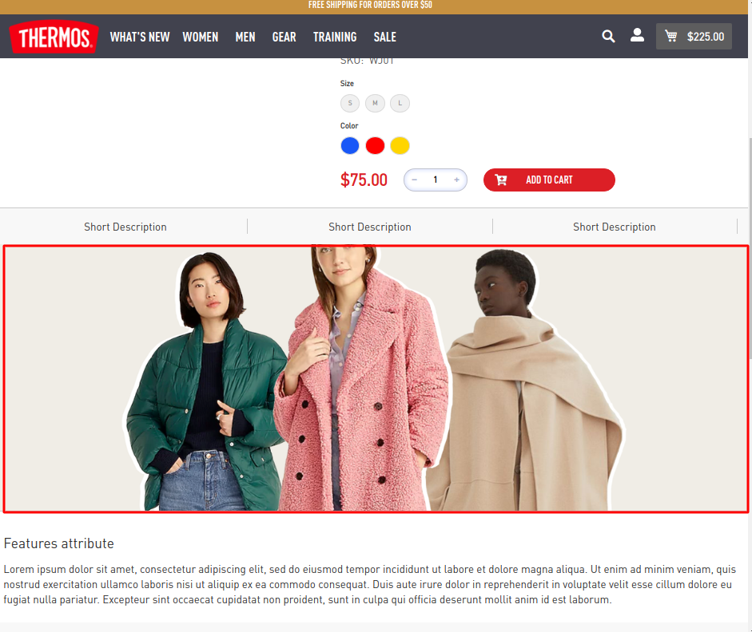

You need to create an attribute

Admin panel – Stores – Attributes – Product - Add New Attribute

Attribute Code : image_attribute

Catalog Input Type for Store Owner: Page Builder

Next :

Admin panel – Stores – Attributes - Attribute Set – Choose your set

Admin panel – Catalog – Products – Сhoose the necessary product - Image attribute – Add HTML Code – Insert Image…

**4.5** Add content for Features attribute

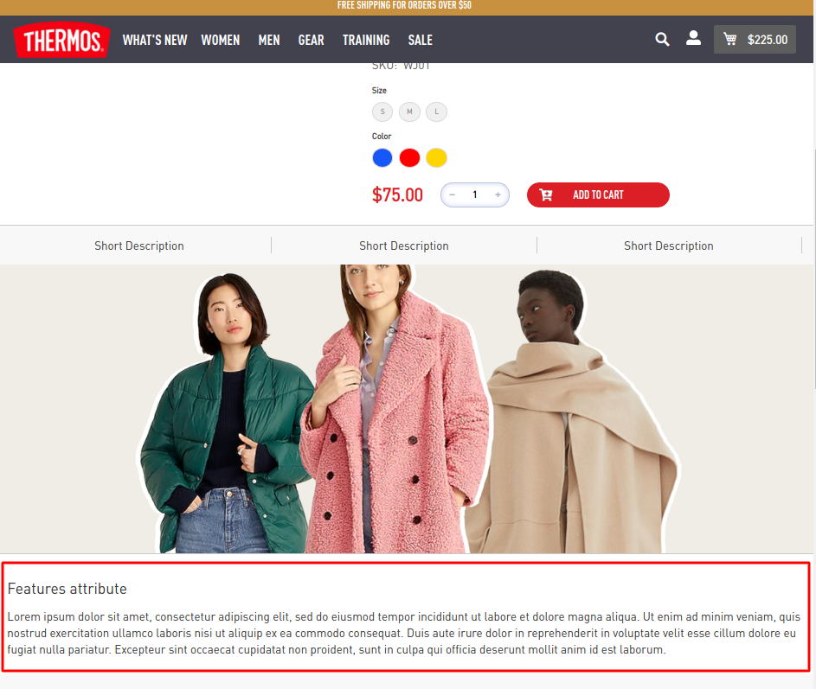

Add New Attribute

Attribute Code : features_attribute

Catalog Input Type for Store Owner: Page Builder

Admin panel – Catalog – Products – Сhoose the necessary product - Features attribute – Add HTML Code

content :

<h2>Features attribute</h2>

<p>Lorem ipsum dolor sit amet, consectetur adipiscing elit, sed do eiusmod tempor incididunt ut labore et dolore magna aliqua. Ut enim ad minim veniam, quis nostrud exercitation ullamco laboris nisi ut aliquip ex ea commodo consequat. Duis aute irure dolor in reprehenderit in voluptate velit esse cillum dolore eu fugiat nulla pariatur. Excepteur sint occaecat cupidatat non proident, sunt in culpa qui officia deserunt mollit anim id est laborum.</p>